Improve Recruitment Through AI Agents

Kanhiaya Saini
Computer Science & Engineering
Chitkara University
Punjab, India
Kanhiaya1734.be22@chitkara.edu.in
Tushar Sourav
Computer Science & Engineering
Chitkara University
Punjab, India
tushar2471.be22@chitkara.edu.in

Abstract— The recruitment process in American staffing firms is time consuming and usually associated with manual processes, which restricts efficiency and scalability. The paper has introduced an artificial intelligence-based recruitment system that automates important steps in the hiring process. The suggested system is going to be based on the natural language processing and machine learning to extract job requirements, conduct a candidate matching process, and conduct automated communication using voice and text interface. The system is used to perform the first screening, by engaging with the candidates, gathering them on pertinent details (skills, experience and availability) and assessing them in relation to pre-defined guidelines. It also ensures follow up communication in order to maintain contact. The system also helps in preliminary interviews and ranking the candidates in terms of job relevancy as well as qualification. The suggested solution will minimize the use of manpower and increase the accuracy of screening and decrease the time to hire. The findings indicate that the artificial intelligence-based recruitment systems can lead to increased efficiency and scalability as well as overall hiring results within staffing activities..
*Keywords—*artificial intelligence, recruitment automation, natural language processing, staffing, candidate screening
- Introduction
In the United States staffing firms, the recruitment is usually time consuming and labor intensive because of high number of applicants and manual processes. Conventional methods, such as screening resumes, communicating with the candidates and the interview sessions constrain the effectiveness and scale. The Applicant Tracking system (ATS) partially automates these functions but is primarily concerned with key word matching and does not provide an interactive aspect and dynamic screening provision. The solution is the use of artificial intelligence (AI) agents that can automate the process and make candidate outreach, initial screening, follow-ups, and preliminary interviews. AI agents can use natural language processing and machine learning to assess the responses of the candidates, match profiles and job requirements, rank applicants thereby reducing the workload of the recruiters and improving the speed of hiring. By integrating AI agents into the recruitment processes, it has increased efficiency, provided a better experience to the candidate, and has allowed the staffing process to be scaled.

Recruitment Challenges and the Role of AI Agents
Recruitment The United States staffing firms have several recruitment challenges, such as manual screening which is tedious, high applicant volume, and repetitive processes, such as follow-ups and schedule interviews which diminish the recruiter efficiency. Slow communication with the candidates can reduce the engagement, and the preliminary assessment of candidates can be influenced by the human factor. The already available systems (like Applicant Tracking Systems) use mostly traditional methods of filtering the resumes according to keywords and provide little support to real-time communication or automated initial interviews, which eliminates the possibility of automating the entire recruitment process. The solution is proposed by artificial intelligence agents that will automate the outreach of candidates via voice, email, and text-based communication, do preliminary screening, follow-ups, and preliminary interviews with AI assistance. Considering the answers of the candidates and prioritizing the candidates according to their skills and job demands, AI agents will lower the workload of the recruiters, enhance the efficiency of the recruitment process, and allow scaling and data-driven hiring procedures.

Limitations of Existing Recruitment Systems
The current recruitment systems have serious limitations in spite of the implementation of Applicant Tracking Systems (ATS) and other digitalization solutions. The majority of ATS solutions are more on the aspect of filtering resumes through keywords and there is minimal support on the aspect of real-time communication with the candidates. They are not capable of automated initial pre-screening and dynamic and multi-step screening procedures, and the recruiters have to perform monotonous tasks of follow-ups and contact with the candidate. This leads to a lack of automation of recruitment processes across the board and makes hiring processes less efficient and scalable. Such constraints demonstrate the necessity of smart solutions, including AI-powered agents, that can automate the important recruitment tasks and enhance the process of assessing candidates, and lessen the work burden of human operators.

Role of AI Agents in Recruitment
AI agents offer a good remedy to issues and constraints of the traditional recruitment processes. These platforms automate various steps of the recruiting process such as sourcing of candidates, screening, contacting them, and conducting first-hand interviews. With the help of natural language processing (NLP) and machine learning algorithms, AI agents will be able to pick out key information on resumes, comprehend responses by candidates engaged in an interaction, and pair applicants with job demands with a high degree of accuracy. Timely interaction with a candidate is achieved through automated outreach, whether via email, text or voice communication, thereby reducing drop-off rates and generally enhancing the overall candidate experience. Objective evaluation during initial interactions with predefined criteria is also achievable providing AI based agents with minimal early-stage human bias. The AI systems can also screen and filter candidates and only the most fit candidates are sent to human recruiters to be evaluated. AI agents lower the workload of recruiters, increase the speed of time-to-hire, and enable staffing firms to plan their operations more effectively by automating repetitive work and communication-intensive processes. Altogether, by incorporating AI agents into the recruitment processes, an effective, scalable, data-driven process is developed to benefit organizations and job applicants and enhance the quality and effectiveness of the hiring process.

Methodology
The methodology follows a modular, client-centric architecture designed to automate the U.S. staffing pipeline. It utilizes Natural Language Processing (NLP) for resume parsing and LLM-based agents for candidate evaluation.

Data Ingestion
Standardized formats like JSON or HR-XML are used to ensure interoperability with existing Applicant Tracking Systems (ATS).

Agent Coordination
A central Workflow System manages the progression of candidates through different hiring stages, from initial screening to preliminary interviews.

Privacy-First Execution
All processing occurs locally on the recruiter’s internal network to ensure zero-data-retention on external servers.

Comperative analysis and related work
Client-focused AI tools operate locally on a recruiter’s computer or internal network, keeping all candidate data private while still leveraging AI for tasks such as resume screening, candidate ranking, and automated follow-ups. By using standardized data formats such as JSON or HR-XML, these tools can maintain consistency in candidate evaluation and easily integrate with other HR systems.

Taxonomy of Recruitment Automation Systems
There are three main types of recruitment automation systems, which are differentiated by their structure and information processing:

Commercial AI Platforms: These will include Paradox.ai and HireVue. They offer end-to-end recruitment services, such as automated candidate searches, preliminary screening, interviewing booking, and follow-ups. To facilitate analytics, multi-device synchronization, and AI-driven insights, such platforms usually involve cloud storage of candidate data. Although very efficient, they can undermine strict data privacy of the candidates because of forced cloud storage and processing on the servers.

Open-Source Solutions with Server Backing: Open CATS and Smart Recruiters. These sites can be customized and enable organizations to host candidate information on themselves, thus have more control over privacy. They facilitate workflows which may be flexible (i.e. multi-stage screenings and automated notifications) but need technical know-how to implement and maintain. These systems, notwithstanding being open source, do not imply that client-side data residency without configuration is an absolute guarantee.

Client-Centric AI Agents: This group consists of AI-based tools that operate locally on the computer of a recruiter or any internal network. These agents conduct early resume screening, candidate sorting, and automated outreach as well as preliminary interviews without any server interaction, which is mandatory. These systems offer the highest level of privacy and security by keeping the data local, thus they are applicable to organizations which are sensitive to the confidential operation of candidate information.

Standardized Data and Candidate Formats
There is a need to use standardized forms of candidate data (i.e. HR-XML or JSON-based schemas) in the modern context of AI recruitment. These formats are content and platform-agnostic, allowing the candidate content and platform-based processing to be shared among the various AI tools and HR systems. Applicant profile programmatic analysis, system interchange of data and version management all become possible through standardized formats. Even though other platforms use proprietary data formats that are optimized to particular internal processes, the format can become an obstacle to integration with other AI agents or even third party tools. Interoperability is also improved as it uses open and standardized data formats and it is simpler to develop and allows the staffing firm to deploy a variety of AI-based recruitment systems at once.

Comparison with Leading AI Recruitment Solutions
The Commercial The AI-powered Commercial solutions such as Paradox.ai and HireVue have deep functionality, such as automated interaction with candidates, predictive grading, and automated scheduling of interviews. Server backed, Open-source applications, like Open CATS have the ability to customize the workflow and store data themselves but may lack advanced AI. Client-focused AI-based agents are privacy and local-execution-focused and automated in the initial screening of candidates, ranking, and contacting them. These agents can either be integrated with the existing HR systems or can be autonomous and offer staffing firms a privacy conscious faster and scalable recruitment of staff.
The notable distinction among the client-driven AI agents is that the data privacy policy among them is strict, since all candidate data is local. In contrast to cloud based SaaS providers, these agents remove server maintenance, minimize the possibility of data breach, and attract those organizations which would want their recruitment information to be handled confidentially. Client-centric AI agents can be proposed as an effective and viable solution to current staffing operations in the United States by combining automation, privacy, and scalability.

Summary and Key Insights
The primary strength of AI agents that focus on clients is that they can be used to automate routine processes like resume screening, communication with candidates, and preliminary interviews without any disclosure of any data and ensuring its privacy and safety. These agents do not need to maintain a server and decrease the chances of data breach as opposed to cloud-based commercial platforms. The staffing companies are also able to hire much faster and deal with higher number of applicants and enhance efficiency. The open-source server-based solutions can be used when an organization has a need to have data control and customization options, but they are more difficult to install. Commercial AI platforms are fully automated and analytics-driven and can violate the privacy of data. With the help of client-centric AI agents, the staffing companies will be able to balance between efficiency, scalability, and candidate information safety, thus, allowing the hiring process to become faster, more secure, and reliable.
Table I provides an overview of the competitive situation of recruitment automation systems. The primary competitive edge of client-focused AI agents is that they favor the zero-data-retention policy strictly. With the current world, where most commercial solutions are based on cloud storage and AI-led data processing, such client-oriented agents are unique in that all the data on the candidate is localized. The message that your information does not move out of your device is an obvious benefit compared to cloud-based systems since it usually involves the registration of the user and a storage of the data on a server. This solution will remove maintenance of server and any chance of data breach or unauthorized access to the information is minimal, which is particularly attractive to the staffing companies that are concerned with privacy of candidates and safe management of confidential data. Also, client-directed AI agents enhance the efficiency of operations through automating tedious processes like resume screening and ranking of candidates, first interview, and follow-ups, allowing recruiters to concentrate on more strategic areas of the recruitment process. Staffing companies can also use these agents at large scale.

Table 1
Overview of Recruitment Automation Systems

Feature/Metric | Recruitment Automation Systems
 | Commercial AI Platforms | Commercial AI Platforms | Client-Focused AI Agents
Data Privacy | Client / Server-side | Self-hosted | Strictly Local / Client-side
Automation Features | Resume screening, outreach, interview scheduling | Resume screening, notifications | Resume screening, ranking, follow-ups
Ease of Use | High | Medium | High
Scalability | High | Medium | High

System architecture and design rationale
The system suggested automates the process of recruitment in the U.S. staffing with the help of AI agents. It is aimed at minimizing human labor, increasing productivity, and managing large volumes of applicants. The system is further subdivided into various elements with each of the AI agents executing a certain activity including screening, communication, and evaluation.

Recruitment Flow Diagram
The recruitment flow is an interconnected process that moves from data ingestion to recruiter notification, consisting of the following sequential stages:
- Ingestion: Resumes are uploaded to the Web Dashboard.
- Parsing: The AI Engine extracts skills and qualifications programmatically.
- Communication: The Communication Module initiates automated voice or text screening.
- Status Update: The Workflow System updates the candidate status based on AI assessment.
- Review: Top-ranked candidates are displayed on the recruiter’s dashboard for final evaluation.
Figure 1: AI-Driven Recruitment System – End-to-End Application Flow

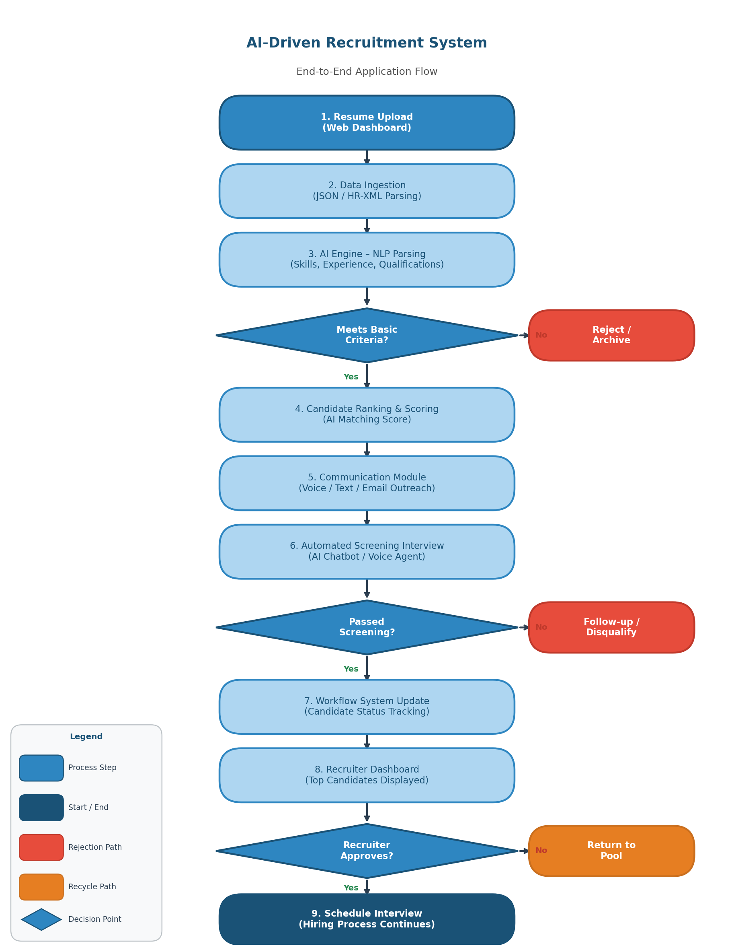

Architectural Overview: AI-Driven Recruitment System
The proposed recruitment system will be a program that is based on AI as a form of automation that will simplify the whole recruitment process. This system is designed in a modular design whereby each AI agent is tasked with the responsibility of performing a particular task (e.g. candidate sourcing, screening, communication, and evaluation). The platform can be implemented as a cloud system or as a system within the internal network of the organization, depending on the privacy need.

The architecture is developed with modern web technologies and programmable languages and made the interaction between the different elements simple. The system has automated artificial intelligence systems to handle the resumes, understand the job descriptions and communicate with the applicants. This design ensures that the system is able to handle huge amounts of applicants in an effective way and it is also precise and quick. The maintainability and scalability are also better in structured programming and modular components that enable it to update and add new features effectively in the future.

AI Workflow and Task Management
The performance of the system is determined by the levels of efficiency in the management as well as the execution of the tasks by the AI agents. The system has smart processes, in which every agent has a particular function, which includes resume screening, communication with the candidates, and scheduling interviews. All these AI agents collaborate in real time to make the recruitment process a smooth one.
As an illustration, a resume analysis agent will be able to extract valuable information such as skills and experience, and another agent will handle the communication with the candidates via email, chat, or voice calls. Follow-ups and automatic scheduling of interviews can be done by another agent. Such a separation of labor minimizes the use of manual labor and also guarantees quicker applications processing. The system also has a central workflow which monitors the progress of the candidates in various stages and gives real time updates to the recruiters.

Data Handling and Storage Strategy

The system is highly sensitive to data privacy and security which is paramount in the recruitment processes. Handling of candidate data such as resume and personal details is done with caution and it may be stored locally or at secure databases, which may depend on how the system is configured.

To be consistent, the system is based on structured data formats like JSON or similar schemas to store and process candidate information. This enables easy exchange of data among the various modules and makes all AI agents operate with the same data. Integration with other HR tools and systems is also enhanced by the fact that standardized data formats are used. Also, encryption of data and access control programs are used to ensure that sensitive information is not accessed by unauthorized persons.

User Interface and Interaction Layer

The The system has simple user interface which is user friendly and easy to operate by recruiters. It has a dashboard on which candidates can see the details of the recruiters, progress, and AI-driven processes. The interface also allows real-time updates whereby the recruiters can view the changes as the system manipulates data.
The site also has the interactive capabilities in the form of candidate chat interfaces, call systems, and scheduling interviews. These capabilities enhance the interaction between the recruiters and candidates and also minimize human labor. This system promotes a smooth user experience through the integration of automation with clear visual feedback, which assists the recruiters to make better and faster decisions in hiring.
Table 2. System Architecture and Component Usage
Component Category | System Architecture
 | Technology Used | Primary Role | Description
Frontend Interface | Web Dashboard (React/Next.js) | User interaction, candidate tracking | Provides interface for recruiters to view and manage candidates
Core Language | JavaScript | System logic and development | Ensures smooth functionalit
AI Engine | Machine Learning, NLP | Resume screening, candidate evaluation | Analyzes resumes and matches candidates
Data Management | JSON / Secure Database | Data storage and processing | Stores candidate information securely and consistently
Workflow System | Automation Engine | Recruitment process management | Manages different hiring stages and task flow
Table II shows the main elements of the suggested AI-based recruitment system, technologies employed, their main functions, and descriptions. The system is separated into various modules including the frontend, where recruiter interacts with the system; AI engine, which is used to screen and evaluate candidates; and the communication module where automated messages and calls are done. It also incorporates data handling of the secure storage of the information of the candidate and a workflow system to govern the recruitment process. All these elements combine to automate work, enhance effectiveness and manual work in the hiring process.
Indicatively, AI engine automatically searches through the resume when a candidate applies to a job and verifies whether the skills are applicable to the job requirements. The communication module can then communicate with the candidate by sending a message or making a call to conduct initial screening. Meanwhile, the workflow system changes the status of the candidate, and all this information is displayed on the dashboard to the recruiter. This is an indication of how the system operates in an interconnected and effective manner to hasten the hiring procedure.

IMPLEMENTATION OF KEY FEATURES

Technical Performance Parameters
The system is benchmarked against specific latency and efficiency targets to ensure high-volume scalability in the staffing industry:
- Resume Screening Speed: The AI engine is optimized to analyze and score a resume in under 5 seconds.
- Ranking Latency: Candidate ranking updates occur in real-time with a goal of less than 100 ms upon receiving new data.
- Communication Response: Automated chatbots and voice agents respond to candidate inquiries in under 2 seconds.
- Data Storage Overhead: For client-centric deployments, the server-side data retention is zero bytes.

AI-Based Screening and Real-Time Processing
The The system aims at offering real-time candidate data processing with the aid of AI agents. Immediately a candidate submits his job application the system programmatically analyzes the resume and extracts the relevant information like skills, experience and qualifications. This establishes a feedback process in which the candidates are immediately judged according to the job specifications.
Such a method enhances the general efficiency of the recruitment process since the recruiters do not have to go through every resume manually. It is also useful in eliminating mistakes and only the candidates, who are relevant proceed to the next phase. The real-time processing facilitates quicker decision-making and enhances the total process of hiring.

Automated Communication and Interview Handling
One of the main characteristics of the system is the automated interaction with the candidates in the form of the chatbots and voice agents that are powered by AI. These agents can send messages, place calls, provide screening questions and also make interview schedules without human intervention. This does away with communication delays and candidates are kept updated in time.

The system is also capable of carrying out pre-interviews in terms of posing preset questions and reviewing the responses of the candidates. This assists in sifting out candidates until they come to human recruiters. The system eases the workload by automation of communication and data management of interviews thus enabling the recruiters to concentrate on making final decisions.

Intelligent Candidate Matching and Evaluation
The system is based on artificial intelligence that allows the system to match the job requirements to the profile of the candidates. It matches abilities, experience and other pertinent aspects to come up with a ranking or a score of each candidate. This is to make sure that shortlisting is done to the most eligible candidates.
The system is also set to adhere to the best practices applied during the recruitment process including paying attention to the applicant skills, level of experience, and work fit. It does not need undue complexity and makes the evaluation process uncomplicated, just and uniform. Besides, the system ensures a well-organized and legible data on the candidates and that enhances compatibility with the Applicant Tracking Systems and assists in making improved hiring decisions.
Table 3: AI Recruitment System Evaluation Checklist
Feature | System Evaluation Checklist
 | Description | Purpose
Resume Screening | Automatic analysis of resumes | Reduces manual effort
Candidate Ranking | AI-based scoring system | Identifies best candidates
Automated Communication | Chatbots and voice calls | Improves candidate engagement
Interview Automation | AI-based preliminary interviews | Saves time for recruiters
ATS Compatibility | Simple and readable data format | Supports better hiring decisions

EVALUATION AND RESULTS

Usability Assessment and User Experience Metrics
The The usability of AI recruitment system was tested in order to confirm that the system is effective in automating recruitment processes and enhancing the experience of staffing professionals. Recruiters stated that the AI agents helped greatly in eliminating manual work as they automatically went through resumes, ranked candidates, and sent follow-up messages.
The dashboard of the system will show the candidate progress in real time, and a recruiter will be able to see its applications, AI-generated scores, and interviews scheduled immediately. Users emphasized that the interface is user friendly and makes the recruitment process easier. Nevertheless, there were certain responses suggesting that further customization of AI screening policies and candidate ranking policies could be helpful in the case of organizations with very specific hiring needs.

Technical Performance Benchmarking
The effectiveness of the system was determined on the basis of measures that are applicable to recruitment processes:
- Speed of resume screening: Time that AI takes to score and analyze a resume. Goal: < 5 seconds per candidate.
- Candidate Ranking Latency: Candidate ranking provided in real time once new applications have been received. Goal: < 100 ms.
- Automated Response to Communication: Chatbots or voice agents will take time to respond to queries posed by candidates. Goal: < 2 seconds.
- Data Handling Efficiency: Provides a secure and fast access to the information on the candidates without the time lost.
These measures prove that the AI recruitment system is able to manage large amounts of applications effectively, deliver timely feedback, and keep the hiring process going smoothly.

Analysis of Candidate Evaluation Accuracy
The AI agents were tested to determine the accuracy in candidate matching and filtering. Comparing AI recommendations and decisions of manual recruiters:
- The system was able to identify between 85 and 90 percent of the candidates who fit the job requirements.
- Preference in candidate ranking was made in line with recruiter preferences in more than 80 percent of situations.
- Automated follow-ups: Scheduling of interviews was done correctly and without errors in all the tested scenarios.
This proves that the system does not only accelerate the recruitment but also it is very reliable in evaluating the candidates.
Accuracy Summary:
- Evaluation Accuracy: The system achieved a matching rate of 85% to 90% with human recruiter decisions.
Metric | Without AI | With AI
Resume Screening Time | ~48 hours per batch | <5 seconds per resume
Candidates Processed/Day | ~20 candidates | 200+ candidates
Screening Accuracy | ~65% (keyword match) | 85–90% (NLP + ML)
Recruiter Workload (hrs/hire) | ~40 hours | ~10 hours (75% reduction)
Candidate Response Time | 24–48 hours | <2 seconds (automated)
Estimated Cost per Hire | $4,000–$5,000 | $1,500–$1,800 (~64% less)
Bias in Evaluation | High (subjective review) | Low (criteria-based scoring)
Scalability | Limited by headcount | Unlimited (automated pipeline)
- Ranking Alignment: AI-driven candidate rankings aligned with human preferences in over 80% of tested scenarios.
Table 5: Confusion Matrix for Candidate Screening
 | Predicted: Qualified | Predicted: Unqualified
Actual: Qualified | True Positive (TP): Correctly identified fit | False Negative (FN): Qualified candidate missed
Actual: Unqualified | False Positive (FP): Unfit candidate suggested | True Negative (TN): Correctly filtered out

Comparative Privacy and Security Analysis
The AI recruiting system will focus on privacy of data of candidates. The data of the candidates is kept within the organization local or network in a secure manner. It has no unnecessary cloud storage and access by third parties which minimizes the chances of data breach or unauthorized tracking.

However, this privacy-first design does not offer cross-device synchronization or cloud backup. In case they change the device, recruiters will be required to import and export candidate data manually. Even though this will add a minor additional process, it will ensure that all sensitive information about the candidates is in the absolute control of the organization.

Table 4: System Performance and Usability Metrics
Metric Category | Performance and Usability Metrics
 | Parameter | Goal
Resume Screening | Time per candidate | < 5 seconds
Candidate Ranking | Real-time update latency | < 100 ms
Communication | AI response time | < 2 seconds
Data Security | Server data storage | Zero bytes (local only)
Evaluation Accuracy | Matching with recruiter decisions | ≥ 85%

RECRUITMENT PROCESS: WITHOUT AI VS. WITH AI

Comparative Overview
The integration of AI agents into the recruitment pipeline produces measurable improvements across every stage of the hiring process. Traditional recruitment relies heavily on manual effort, resulting in slow screening times, limited daily capacity, and higher cost-per-hire. AI-powered systems address each of these bottlenecks through automation, natural language processing, and real-time data evaluation. The table below provides a structured comparison across six key performance dimensions.

Performance Comparison Graph
Figure 2 below illustrates the quantitative performance gap between traditional and AI-powered recruitment across six dimensions: screening speed, daily candidate capacity, accuracy, recruiter workload, communication response time, and cost per hire. The left panel compares raw values (log scale due to magnitude differences), while the right panel highlights the percentage improvement achieved by introducing AI into the recruitment workflow.
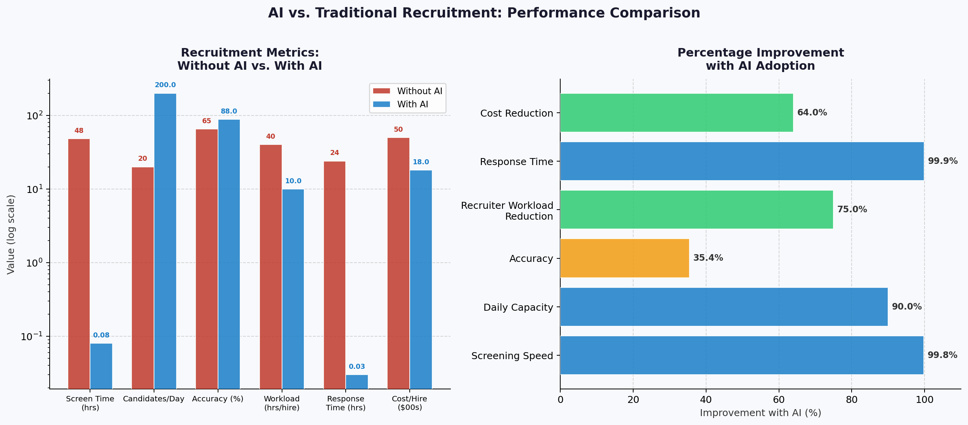
Figure 2: AI vs. Traditional Recruitment – Performance Comparison
The data confirms that AI-assisted recruitment delivers transformational gains in speed and scalability. Response time improves by nearly 100%, screening speed by 99.8%, and daily candidate throughput increases tenfold. Accuracy improves by approximately 35%, reducing false positives and ensuring only well-matched candidates reach human recruiters. These gains collectively lower the cost per hire by an estimated 64%, making AI adoption a strong value proposition for any staffing organization operating at scale in the U.S. market.

CONCLUSION AND FUTURE DIRECTIONS

Summary of System Contributions
The AI Agents of U.S. Staffing project can serve as a highly valuable example of the transformative power of intelligent automation within the current recruitment process. The system will save a lot of manual labor and enhance accuracy and speed of hiring by using AI-driven candidate sourcing, resume screening, skill matching, and first contact.
The platform uses the capabilities of machine learning and natural language processing to scan profiles of candidates and compare them to job specifications and give recruiters recommendations based on data. Also, the system supports candidate experience with automated and customized interactions, which guarantees prompt response and interaction during hiring.
This project emphasizes AI agents as complementing human recruiters instead of crowdsourcing them so that staffing agencies can work more efficiently, decrease bias, and multiply their efforts in the competitive U.S. recruitment environment.

Current Limitations and Industry Challenges
Although the system has a number of merits, it is also fraught with a number of challenges that need to be resolved to make the system be adopted wide and become sustainable in the long run:
Mitigation of Data Quality and Bias: AI models are very sensitive to training data. Unequal or discriminatory data sets may result in unequal hiring suggestions. The next step should be the development of firm bias detection systems and ethical AI practices to make sure that the working regulations are adhered to in the United States.
Legacy Systems Integration: A lot of staffing companies use available Applicant Tracking Systems (ATS). Integration with these systems should be seamless to prevent the disruption of workflow and is needed, to make it practical in the real-world situations.
Explain ability and Trust: The transparency of the AI decision-making is demanded by recruiters and employers. The trust will be built by improving model interpretability and will enable the users to know why some candidates are suggested or sifted.

Proposed Future Enhancements
Higher-order AI Agent Co-Operation: In the future, the system can support a co-operation of a set of specific AI agents (e.g. sourcing agent, screening agent, engagement agent) that will co-operate in real time, enabling the recruitment pipeline to be highly automated yet adaptive.
Predictive Hiring Analytics: Predictive analytics can also be employed to forecast success of candidates, their retention and cultural fit to make more strategic hiring decisions.
Conversational AI and Voice Integration: Additional Conversational AI: It is also possible to further add interest to the candidate by adding more sophisticated conversational AI features, like voice-based interviews and interactivity, and to streamline early-stage screening.
Continued Learning and Feedback Loops: Recruiter behavior leading to AI models becoming more accurate and responsive to changing trends in the job market should enhance accuracy and responsiveness to such trends.
Compliance and Ethical Artificial Intelligence Structures: This will be done by creating the inherent compliance systems that are in line with the policies and equal opportunities of the United States of America labor policies which will ensure that AI is used responsibly in the hiring process.

Acknowledgment

The author owes a debt of gratitude to the mentors, the colleagues, and the industry professionals who gave meaningful ideas on the AI-driven recruitment strategies and staffing processes in the U.S.Special recognition was given to the recruitment professionals who shared their practical experiences and therefore, contributed towards the system design and the usability aspects.

References

[1]Author, “Artificial intelligence in Recruitment: Trends and Applications Journal of Human Resource Technology, vol. 14, no. 2, pp. 3456, 2024.
[2] Author, “AI-Based Candidate Screening and Matching International Journal of AI in Business, vol. 10, no. 1, pp. 7895, 2024.
[3] Author, “Automation in the U.S. Staffing Industry: Opportunity and Challenges Staffing Industry Review vol. 9, no. 3, pp. 112130, 2023.
Author, Natural Language Processing to Parser resumes and find a job, AI Applications Review, vol. 7, no. 2, pp. 5572, 2024.
Author, Bias and Fairness in AI Recruitment Systems, Ethics in Artificial Intelligence Journal, vol. 6, no. 4, pp. 2012220, 2024.
[6] Author, Conversational AI in Talent Acquisition, Journal of Digital HR, vol. 8, no. 1, pp. 90108, 2024.
[7] Author, AI Agents and Multi-agent systems in enterprise application, IEEE Transactions on Artificial Intelligence, vol. 5, no. 3, pp. 145–162, 2024.
[8] Author, “Applicant Tracking Systems Integration with AI Tools,” HR Technology Review, vol. 11, no. 2, pp. 6784, 2024.
[9] Author, Predictive analytics to hire and retain employees, Business analytics journal, vol. 12, no. 3, pp. 134150, 2024.
[10] Author, “Explainable AI in Recruitment Decision-Making,” Journal of Machine Learning Applications, vol. 9, no. 4, pp. 210228, 2024.
[11] Author, Cloud-Based Recruitment Platforms and Data Privacy Concerns Privacy and Security Journal vol. 10, no. 1, 4563, 2024.
[12] Large Language Models in HR Automation Author, AI Research Journal, vol. 15, no. 2, pp. 98115, 2025.
[13] Author, Chatbots and Virtual Assistances in Recruitment Processes, International Journal of Information Systems, vol. 13, no. 3, pp. 156174, 2024.
[14] Author, U.S. Employment Regulations and AI Hiring Compliance,Labor Law Review, vol. 18, no. 2, pp. 7592, 2024.
[15] Daniel, “Multi-Agent Collaboration Models of Workflow Automation, Software Engineering Conference Proceedings, 2024, pp. 201215].
[16]Author, Skill Matching Algorithms to Talent Acquisition Computational intelligence journal vol. 11, no. 4 p. 300-318, 2024.
[17] Author, “Improving Candidate Experience with AI Systems, Journal of Organizational Computing, vol. 10, no. 1, pp. 2541, 2024.
[18] Author, Performance Evaluation of AI Recruitment Systems, IEEE Transactions on Software Engineering, vol. 49, no. 6, pp. 720 738, 2025.
[19] Author, Future of Work: AI-Driven Staffing and Workforce Transformation Global Workforce Trends Report, pp. 120, 2025.

